Survey of COVID-19 Vaccine Safety Assessment Activities Presented on VIEW-hub

Methods

Updated December 6, 2022

Prepared by:

International Vaccine Access Center,
Johns Hopkins Bloomberg School of Public Health

and

Coalition for Epidemic Preparedness Innovations

For comments or questions, please contact: Marley Jurgensmeyer at mjurgen4@jhu.edu.

Background
Several rare severe adverse events have already been observed with commonly used COVID-19 vaccines, but published evidence in December 2021 was limited to vaccines used by high income countries. The ability to assess their occurrence for all Covid-19 vaccines used by countries worldwide and to detect other unknown and unexpected serious adverse events (SAEs) is critical to understanding the risks associated with Covid-19 vaccine use globally. To support the COVAX Vaccine safety working group (VSWG), the World Health Organization Pharmacovigilance team (WHO-PV) and the Coalition for Epidemic Preparedness Innovations (CEPI), with support from the Johns Hopkins International Vaccine Access Center (IVAC), assessed the landscape of Covid-19 Active Vaccine Safety Surveillance (AVSS) activities. This assessment was intended to better understand the potential sources of evidence pertaining to safety signal detection and evaluation beyond the published evidence, including where they will or are currently being conducted and their key characteristics, and to identify gaps that may need to be filled.

Overview of Survey of Planned and Ongoing Studies
A survey to identify planned or on-going surveillance activities (including studies) assessing adverse events following COVID-19 vaccination was conducted December 2021 to February 2022. Survey responses are presented on the Covid-19 safety module on the VIEW-hub.org website alongside published studies by clicking the “Include planned or ongoing studies” box located above the table of studies. The survey targeted observational or low-interventional studies (i.e., AVSS studies) conducted after COVID-19 vaccines became available to the general population (i.e., clinical trials are excluded). The survey was sent to 100s of individuals at various institutions worldwide, including WHO regional offices, universities known to be evaluating COVID-19 vaccines, government public health institutions, vaccine manufacturers and more. The survey was sent via email by individuals at WHO Headquarters and CEPI.

Vaccine manufacturers were asked to provide details of their respective Risk Management Plans (RMPs), which describes specific planned safety studies for post-licensure commitments (i.e., observational studies post-introduction) in countries where their vaccines are being used.

The survey results only represent those who voluntarily shared their study details (or for RMPs were publicly available) and are not comprehensive of all planned and ongoing vaccine safety studies for COVID-19 vaccines worldwide.

Information Collected in the Survey
The survey was developed with input from WHO Headquarters and CEPI. The survey collected information on COVID-19 AVSS activities evaluating adverse events following immunization (AEFI), which WHO defines as any untoward medical occurrence following immunization which does not necessarily have a causal relationship to the vaccine. The adverse event may be any unfavorable or unintended sign, abnormal laboratory finding, symptom or disease. Serious AEFIs are defined by WHO as all-cause deaths and hospitalizations.

Information collected included in what countries and targeted populations (e.g., adults, older adults, pregnant women, children, etc.) they were being conducted, which COVID-19 vaccine products would be evaluated (if known), what surveillance setting and study designs would be used, and which adverse events following immunization would be monitored (see Appendix 1 for survey form).

The Brighton Collaboration created a list of Adverse Events of Special Interest (AESI) pertaining to COVID-19 vaccines (see Appendix 2 and here). Those that were commonly mentioned in activities targeting specific AESIs have been flagged and are searchable using the ‘Adverse Events’ drop-down menu on the table listing studies in the VIEW-hub safety module.

This project was conducted by: Maria Deloria Knoll, PhD, Parisa Shamaei Zadeh, and Marley Jurgensmeyer at the International Vaccine Access Center, Department of International Health, Johns Hopkins Bloomberg School of Public Health, Baltimore, Maryland, USA; Emmanuelle Espié, DVM, MPH, PhD, and Rebecca Chandler, MD, at the Coalition for Epidemic Preparedness Innovations (CEPI), Oslo, Norway; and Noha Iessa, MPharm, PhD, and Shanthi Narayan Pal, MPharm, PhD, at the World Health Organization (Headquarters), Geneva, Switzerland.

Funding: Support for this project was provided by the Coalition for Epidemic Preparedness Innovations (CEPI).

Appendix 1: Survey Form

Landscape analysis on Active Vaccine Safety Surveillance (AVSS) of
COVID-19 vaccines
Conducted by the Coalition for Epidemic Preparedness Innovations (CEPI)
(with assistance from The International Vaccine Access Center (IVAC) at the Johns Hopkins Bloomberg School of Public Health)
Questionnaire – version November 3, 2021

Objective: To better understand the current planning, the status of global, national, or regional governmental and non-governmental activities on active vaccine safety surveillance (AVSS) of COVID-19 vaccines post-authorization, complementing passive pharmacovigilance. This will help WHO and other stakeholders to identify gaps in Vaccine safety evidence data for informing global vaccine policy.

Data may be shared with stakeholders, including policy makers, funders, and study implementers. Some data, such as the location of studies and type of study proposed, might be made publicly available on a public website in the future. If this is a concern, please note that at the end of the questionnaire.
Instructions: Please answer the below questions for all AVSS activities which are at least at the stage where there are concrete plans (e.g., budget and/or protocol) for an AVSS. As progress is made on the studies, please provide updates via email response. This form will allow you to fill out information on one AVSS. If you are submitting information on more than one AVSS, please submit separate forms.

- Email Address

- Name of the institution

- Name of the Respondent

- Have you secured funding for this AVSS?
- If yes, please list funding source

- Study name or number

- Vaccines being evaluated

- Country or countries the vaccine safety study is conducted in (Choose all that apply.)

- Safety risks under evaluation*
- Any AEFI
- Serious AEFI
- Specific AEFI – please describe

- Study setting (Choose all that apply.)
  - Hospital / Clinic records
  - Multicenter site
  - Self- reporting / questionnaires
  - Population-based registries / Health and demographic surveillance sites
  - Healthcare databases / Large linked databases
  - Other – please describe
- Population being investigated (Choose all that apply.)
- Healthcare workers
- General adult population
- Elderly >= 65 years
- Persons with comorbidities
- HIV infected
- Other immunocompromised (e.g., transplant patients, autoimmune or inflammatory disorders)
- Children
- Pregnant/breastfeeding women
- Others – please describe

- Study design methodology being used (Choose all that apply.)
  - Cohort-event monitoring (CEM)
  - Sentinel site surveillance
  - Case-control
  - Case-cohort
  - Self-controlled case series
  - Enhanced / targeted reporting/spontaneous reporting
  - Clinical trial
  - Other – please describe

- What stage is your study currently? (Choose all that apply.)
- Fundraising
- Protocol developed
- Undergoing ethical review
- Data collection
- Analysis/writing
- Completed
- Published/reported externally
- Not Applicable

- Enrollment start date (Month/Year)
(record planned start date if not begun)

- When do you expect to have the results? (Month/Year)

- Summary of the AVSS approach or project:

- Any additional comments or details about the study?

- Is this study mentioned in an RMP document? If so,
        - Please provide the title or a description
        - Please provide a link.

- Is a description of this study publicly available?
        - If yes, please provide a link
        - If no, please indicate where information can be found

- Are results publicly available? If so,
        - Please provide a link

- Further questions, comments, or concerns of data availability

*These were not defined in the survey but WHO defines adverse events following immunization (AEFI) as any untoward medical occurrence following immunization which does not necessarily have a causal relationship to the vaccine. The adverse event may be any unfavorable or unintended sign, abnormal laboratory finding, symptom or disease. Serious AEFIs are defined as all-cause deaths and hospitalizations. Specific AEFIs indicate selected AEs are being investigated, such as by a search for specific terms in a database or clinical record review.

Appendix 2: Brighton Collaboration list of Adverse Events of Special Interest

The Brighton Collaboration created a list of Adverse Events of Special Interest (AESI) pertaining to COVID-19 vaccines (below and here). The AESIs are categorized according to level of association: those seen with COVID-19 disease, those that have a proven or theoretical association with immunization in general, and those that have a proven or theoretical association with specific vaccine platforms.

For activities targeting specific AESIs, commonly mentioned AEs described on the Brighton Collaboration list are searchable using the ‘Adverse Events’ drop-down menu on the table listing studies in the VIEW-hub safety module.

Table. Brighton Collaboration list of Adverse Events of Special Interest (AESI)
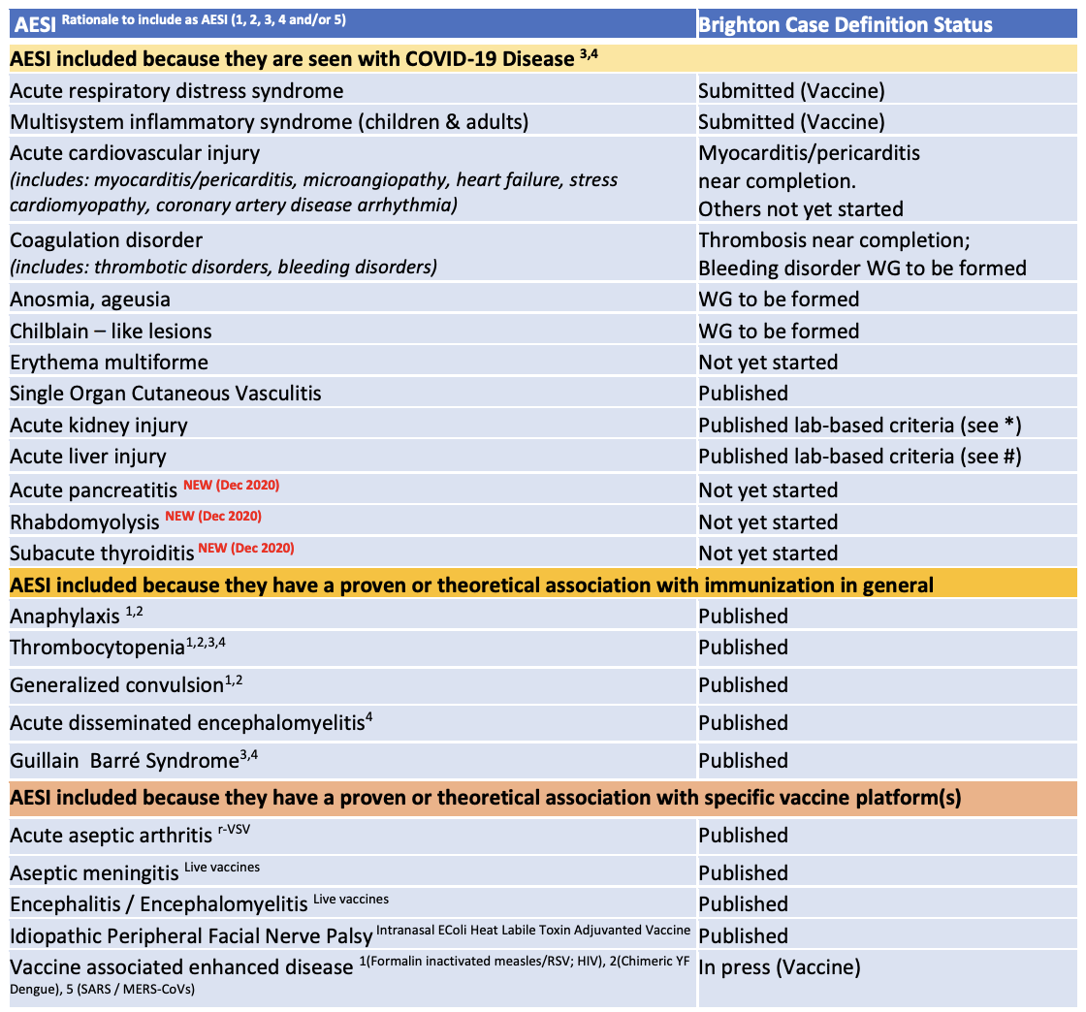
¹Proven association with immunization encompassing several different vaccines
²Proven association with vaccine that could theoretically be true for novel COVID-19 vaccines
³Theoretical concern based on wild type disease immunopathogenesis
⁴Theoretical concern related to viral replication during wild type disease
⁵Theoretical concern because it has been demonstrated in an animal model with ≥ 1 vaccine platform
*Acute kidney injury – international consensus definition proposed by the Kidney Disease Improving Global Outcomes expert consensus group (www.kdigo.org)
- Increase in serum creatinine by ≥ 0.3 mg/dl (≥26.5 umol/l) within 48 hours; OR
- Increase in serum creatinine to ≥ 1.5 times baseline, known or presumed to have occurred within prior 7 days OR
- Urine volume ≤0.5 ml/kg/hour for 6 hours
# Acute liver injury – definition as used in majority of COVID-19 publications (but no international consensus):
- > 3-fold elevation above the upper normal limit for ALT or AST OR
- > 2-fold elevation above the upper normal limit for total serum bilirubin or GGT or ALP

